PROJECT C-3
Retail Customer Retention Analytics – TESCO
Video Link = https://drive.google.com/file/d/1LlMfSWT6TxdpUol4yRYwB3a-KnP3-AuX/view?usp=sharing

Task 1: Data Modeling and Cleaning
Goal: Prepare the data for analysis
● Use Power Query Editor to load and transform the datasets.
○ Remove duplicate rows based on key columns (e.g., Customer_ID, Store_ID)
○ Format columns: Convert dates, ensure numeric types for Amount, Points, etc.
○ Handle missing or null values appropriately (e.g., filter or replace)
● Create calculated columns:
○ Membership_Duration = Today - Membership_Since
○ Add a Transaction_Year and Transaction_Month column from Transaction_Date ● Create a basic Data Model view
○ One-to-Many: Customer_Demographics → Transactions, Loyalty_Program, Churn_Labelled_Customers
○ Many-to-One: Transactions → Store_Locations

SOLUTION TASK-1
* first I remove the duplicate data by using power query ,to access power query we have to do home-> transform data
* so I clean all the data by removing the duplicate and make data in proper data type

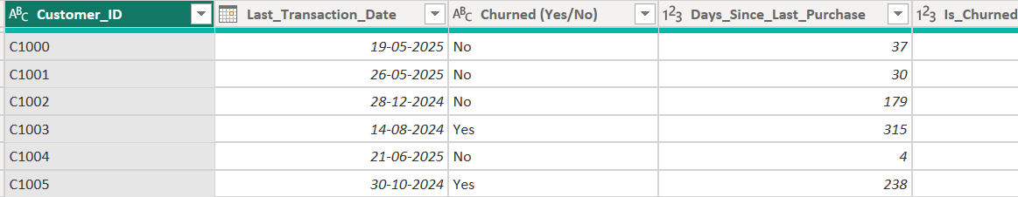
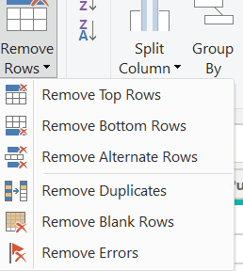

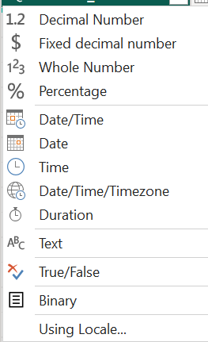
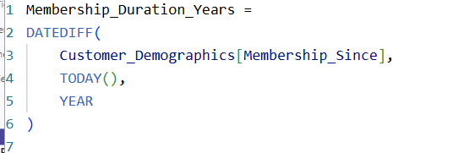

- membership duration year done by measure

- Add a Transaction_Year and Transaction_Month column from Transaction_Date
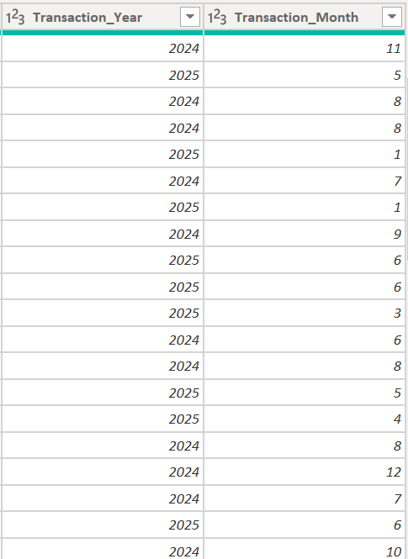
It is done in power query by column from the example of the column transaction_Date
● Create a basic Data Model view
○ One-to-Many: Customer_Demographics → Transactions, Loyalty_Program, Churn_Labelled_Customers
○ Many-to-One: Transactions → Store_Locations
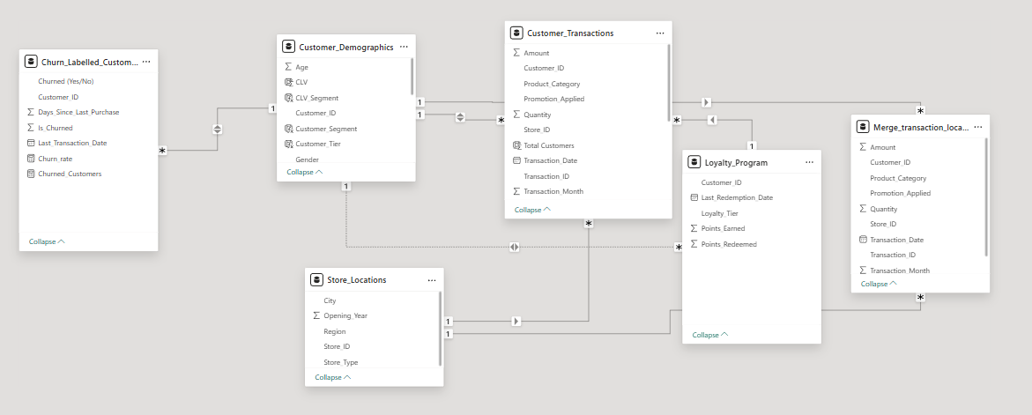

Task 2: Churn and Retention Metrics (10 Marks)
Goal: Identify churn trends across segments
● Create a Churn Rate card: (Churned Customers / Total Customers) * 100
● Visualize churn rate by:
○ Region
○ Income Group
○ Store Type (via store join)
○ Identify top 5 segments with highest churn %
● Create funnel chart: Total Customers → Repeat → Churned

- Create a Churn Rate card: (Churned Customers / Total Customers) * 100
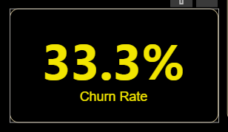

Visualize churn rate by:
○ Region
○ Income Group
○ Store Type (via store join)
○ Identify top 5 segments with highest churn %
● Create funnel chart: Total Customers → Repeat → Churned
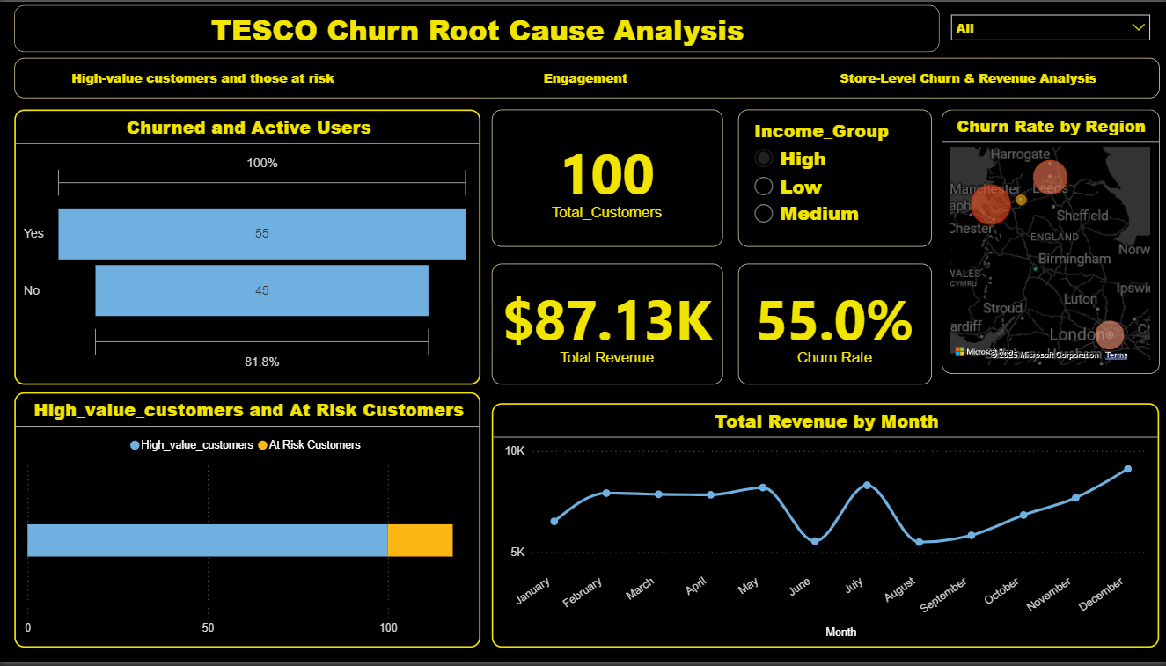

Task 3: Repeat Purchase Analysis (10 Marks)

Goal: Understand customer loyalty through repeat behavior
● Create a measure: Low-Tier Customers: (2-4 purchases) Mid-Tier Customers: (5-10 purchases) High-Tier Customers: (11+ purchases)
● Compare avg. purchase frequency by:
○ Region
○ Age Group
○ Loyalty Tier
● Identify product categories most frequently bought by loyal customers

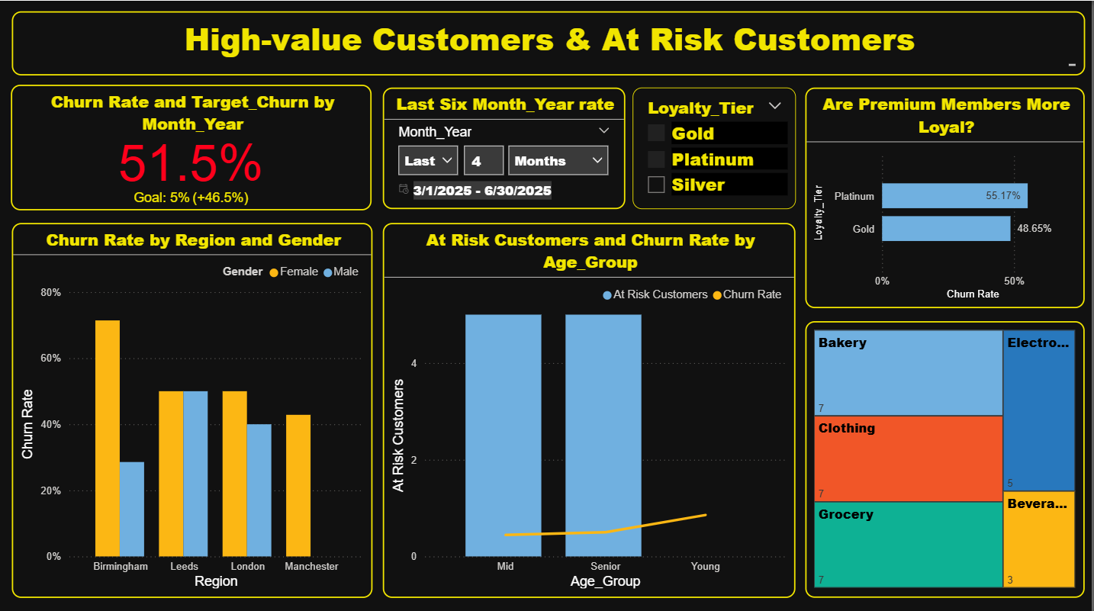

Task 4: Promotion & Loyalty Impact (10 Marks)
Goal: Evaluate how promotions and loyalty tier affect retention
● Create Measure:
○ % of transactions where promotion was applied
○ Avg. purchase amount with vs without promotion
● Compare churn rate across loyalty tiers
● Show Points Earned vs Redeemed by Tier using clustered column chart
● Recommend how to improve redemption and retention
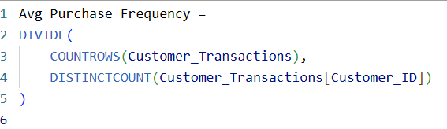

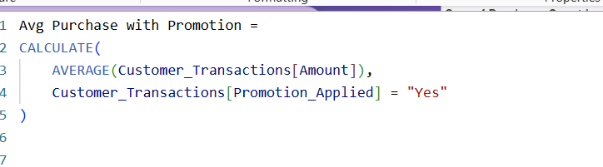
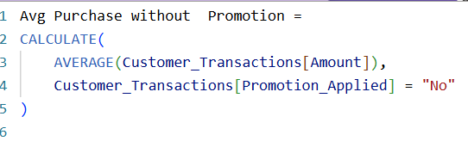
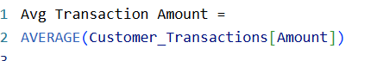

● Compare churn rate across loyalty tiers
● Show Points Earned vs Redeemed by Tier using clustered column chart
● Recommend how to improve redemption and retention

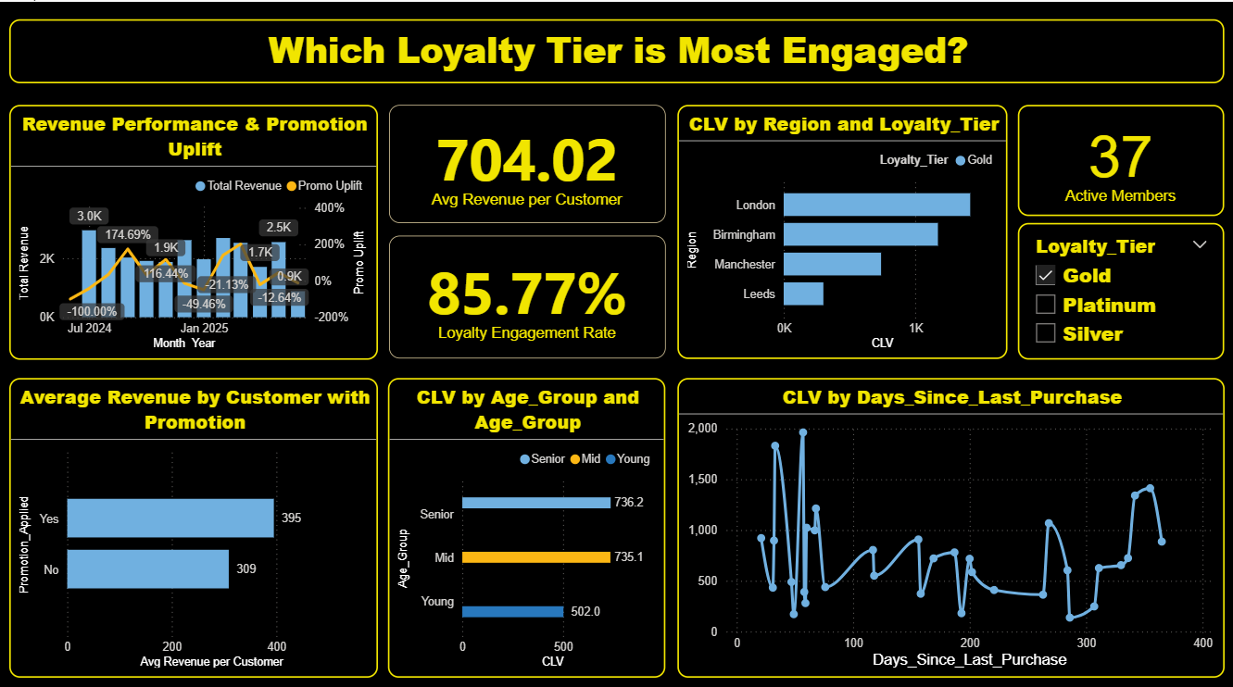

Task 5: Store Performance vs Retention (10 Marks)
Goal: Link store characteristics to retention outcomes
● Merge Store_ID from transactions with Store_Locations
● Visualize:
○ Avg. transaction amount by store type
○ Churn rate by store region
○ Correlation between store opening year and retention
● Suggest where to run store-specific campaigns

SOLUTION TASK-5

● Merge Store_ID from transactions with Store_Locations
You can merge Store_Location and Customer_Transactions tables by matching the common key Store_ID.
Home → Merge Queries → Select Store_ID in both tables → Choose Join → Expand columns.
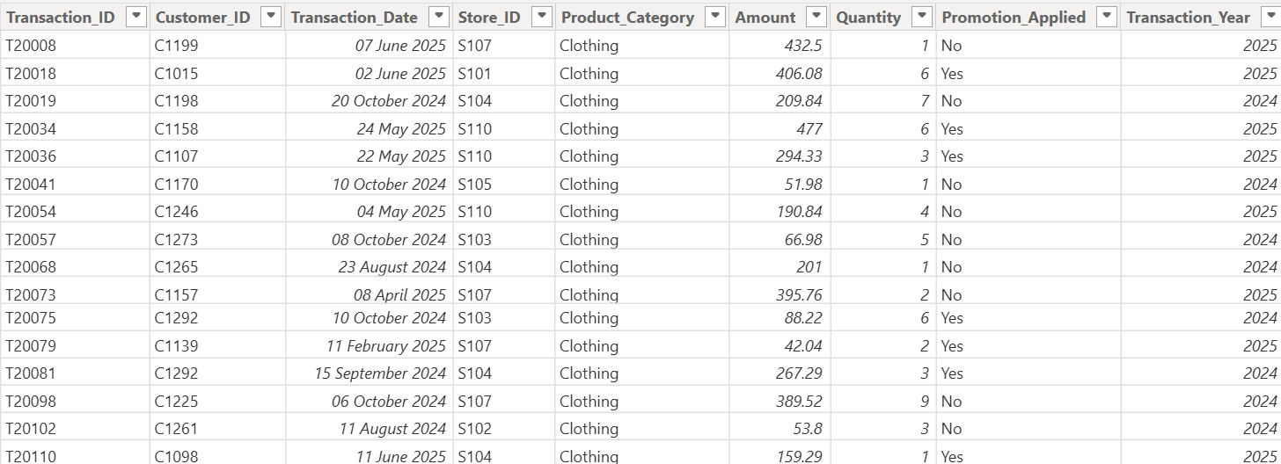

* Visualize:
○ Avg. transaction amount by store type
○ Churn rate by store region
○ Correlation between store opening year and retention
● Suggest where to run store-specific campaigns

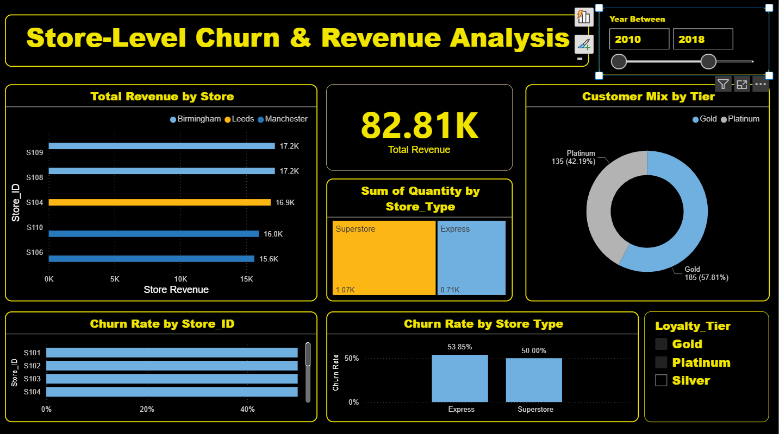

Task 6: Customer Value (CLV) Analysis (10 Marks)

Goal: Identify and prioritize high-value customers Calculate CLV = Total Amount Spent / Membership Duration (in years)
● Segment customers into:
○ Low (Bottom 25%)
○ Medium (Mid 50%)
○ High (Top 25%)
● Visualize:
○ CLV vs Days Since Last Purchase
○ CLV by Loyalty Tier and Region

S0LUTION TASK-6

Calculate CLV = Total Amount Spent / Membership Duration (in years)
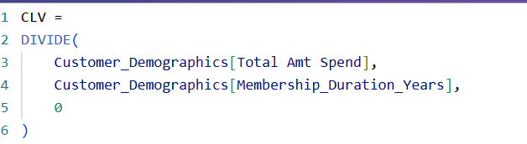

● Segment customers into:
○ Low (Bottom 25%)
○ Medium (Mid 50%)
○ High (Top 25%)
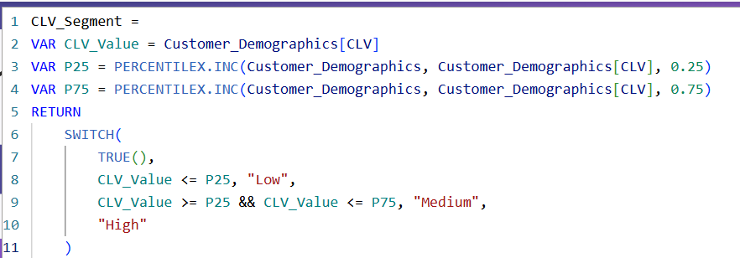
● Visualize:
○ CLV vs Days Since Last Purchase
○ CLV by Loyalty Tier and Region

Task 7: Final Dashboard and Executive summary (20 Marks)
Goal: Communicate insights for business action
● Create a multi-page Power BI report:
○ Page 1: Overview KPIs (Churn, CLV, Repeat Rate)
○ Page 2: Loyalty & Promotion Impact
○ Page 3: Store and Region Insights
○ Page 4: Customer Segmentation (Churned, Repeat, High-Value) Add slicers: Region, Income Group, Loyalty Tier, Store Type
● Create a card or textbox summarizing top 3 recommendations:
● What should TESCO do to retain more customers?
● Where should they focus next?

Page 1: Overview KPIs (Churn, CLV, Repeat Rate)
Add slicers: Region, Income Group, Loyalty Tier, Store Type

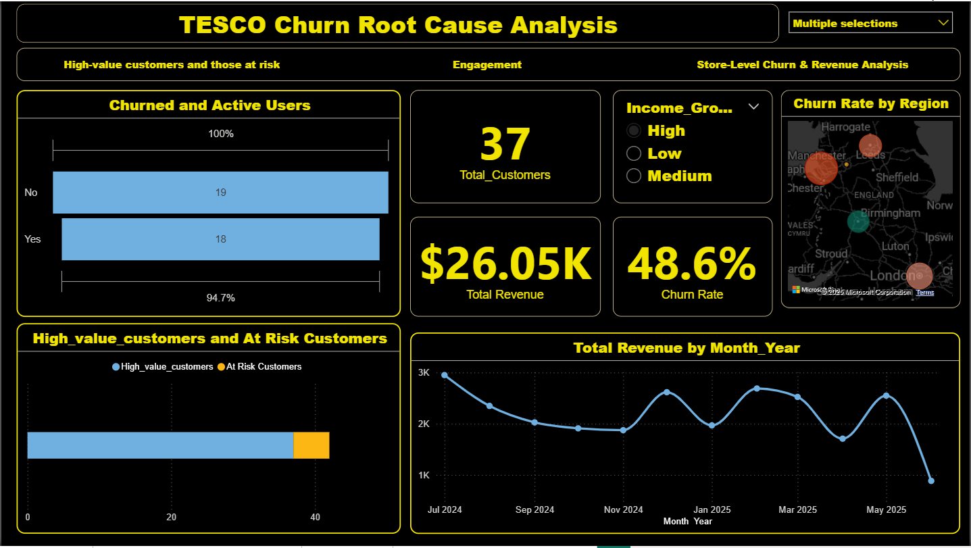

Page 2: Loyalty & Promotion Impact

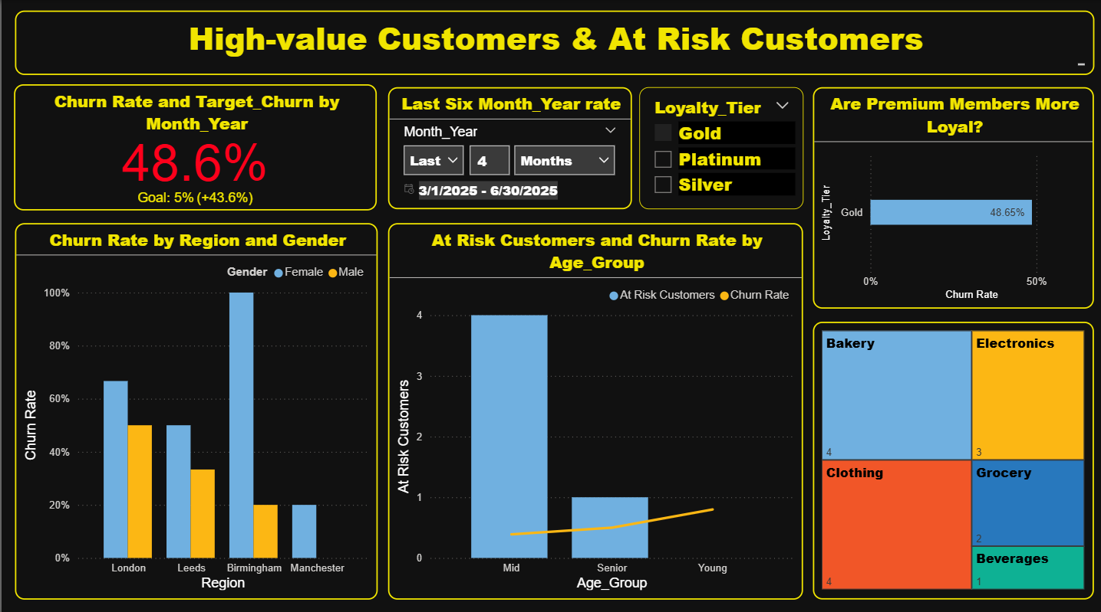

Page 3: Store and Region Insights
● Create a card or textbox summarizing top 3 recommendations:
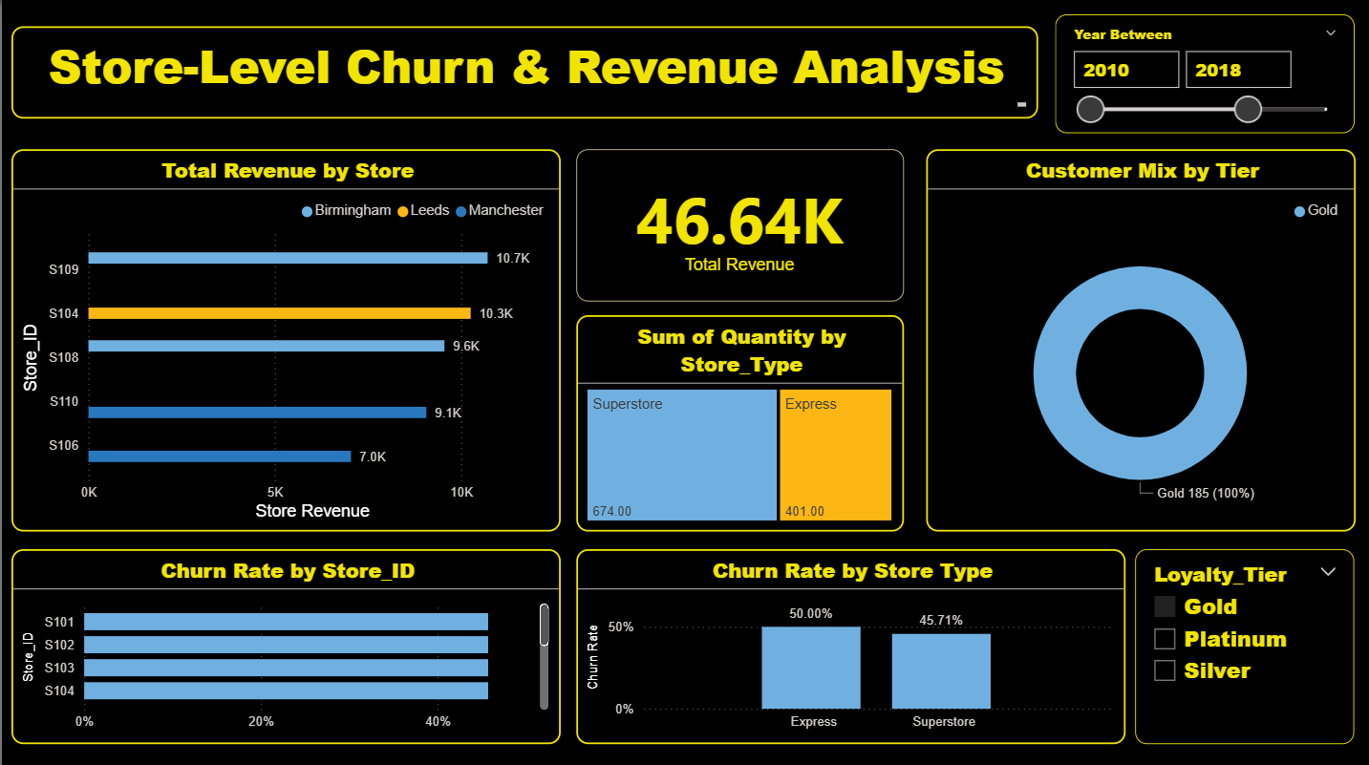

Page 4: Customer Segmentation (Churned, Repeat, High-Value)
● What should TESCO do to retain more customers?

